Part No.﹕1L0545W21A0CB201
§ Standard 5mm diameter package.

Characters
§ High intensity.

Outline Dimensions

§ All dimensions are in millimeters（inches）.
§ Tolerance is ±0.25（.010）㎜ unless otherwise noted.
§ Protruded resin under flange is 1.0㎜（.04）max.

Absolute Maximum Ratings（Ta=25℃）
Item | Symbol | Value | Unit
Power Dissipation | PD | 120 | mW
DC Forward Current | IF | 30 | mA
Pulsed Forward Current | IFP | 100* | mA
Reverse Voltage | VR | 5 | V
Operating Temperature | Topr | -25 ~ +80 | ℃
Storage Temperature | Tstg | -40 ~ +100 | ℃
Soldering Temperature | Tsol | 260for5sec | ℃
* Duty 1/10 Pulse Width 0.1ms △ At the position of 4mm from the bottom
of the package
Electrical-Optical Characteristics（Ta=25℃）

ITEM |  | MATERIALS
Resin(Mold) |  | Epoxy
Lens Color Code | C | Water Transparent
Lens Color Code | T | Colored Transparent
Lens Color Code | M | White Diffused
Lens Color Code | D | Colored Diffused
Lead Frame |  | Ag Plating Iron Alloy
Dice |  | InGaN

Directive Characteristics（Ta=25℃）

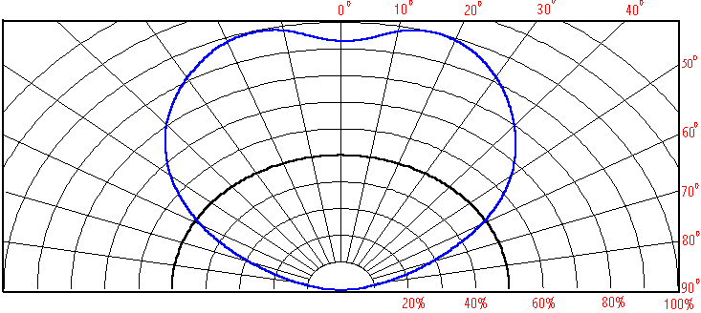

Parameter | Symbol | Value |  |  | Unit | Test condition
Parameter | Symbol | Min. | Typ. | Max. | Unit | Test condition
Forward Voltage | Vf | ﹍ | 3.2 | 4.0 | V | If=20mA
Luminous intensity | Iv | 420 | 550 | ﹍ | mcd | If=20mA
Wavelength | X(&λd) | ﹍ | 0.2938 |  | (nm) | If=20mA
Wavelength | y | ﹍ | 0.2879 | ﹍ | ﹍ | If=20mA
Reverse Current | Ir | ﹍ | ﹍ | 1 | μA | Vr=5V
Viewing angle | 2θ1/2 | ﹍ | 120 | ﹍ | Deg | If=20mA
Spectral half bandwidth | △λ | ﹍ |  | ﹍ | nm | If=20mA

